The Republic of Uganda

PDM SECRETARIAT/ MINISTRY OF LOCAL GOVERNMENT

IMPLEMENTATION OF NRM MANIFESTO 2021-26, CASE OF PARISH DEVELOPMENT MODEL (PDM) IN LANGO, ACHOLI & WEST NILE

21ST MARCH, 2023

  - INTRODUCTION

  - The report presents quick synopsis of the implementation of the Parish Development Model (PDM) so far- with a focus on Lango, Acholi and West Nile sub-regions of Uganda. This is within the realm of the PDM being a Government multi-sectoral strategy to reducing poverty, by moving the 39% households (i.e. 3.5 million households or 16.1 million Ugandans) under subsistence sector into the money economy nationwide.

  - Further that the PDM emphasises the “Whole-of-Government” approach in delivering, while working with both the State and Non-State Actors in a participatory manner to organize, harmonize and have citizens’ feedback in the delivery of public and Private Sector interventions at the Parish/ Ward, aimed at: a) Food security b) Wealth creation c) Employment generation; and d) Improved service delivery focused on the Parish – in advancing the NDP III, NRM Manifesto 2021-2026 for inclusive socio-economic transformation goal.

  - Based on community outreach and mobilisation as an entry point (Pillar 5) to inform Data profiling (Pillar 6 on PDMIS); among other aspects, the subsisting communities in this phase of PDM implementation are expected to receive the Parish Revolving Fund (under the overall broader 6 interventions of Financial Inclusion - Pillar 3) to invest in their enterprises to advance Pillar 1 (on Agricultural value-chain development i.e. production, processing, storage and marketing) on-farm and off-farm. Even so, all the 7 PDM Pillars mutually reinforce once another.

2.0 IMPLEMENTATION STATUS OF PARISH DEVELOPMENT MODEL (PDM)- LANGO, ACHOLI, WEST NILE

The following has been achieved so far from FYs 2021/22 and 2022/23:

  - Community outreach, mobilisation and sensitization undertaken: This was the cornerstone entry point for PDM across the country, including northern Uganda. Having trained a District PDM Core Team of members of the TPC (Planner, DPO, DCO, DCDO, Information, IT, etc), there was deliberate sensitisation cascading down from the key State actors at the District, to the Sub-county leadership and Parishes/ Wards, even though a lot more is still required to continuously support the uptake of the “PDM gospel”. Those targeted for sensitisation were the Political and technical leaders (Northern Uganda Parliamentary caucus, Councillors including DEC, Women councils, Youth leaders, Disability councils, RDCs, members of TPCs). Others included Development Partners (e.g. UNDP in northern Uganda) and the Non-State actors like the Media, Academia and Non-Governmental Organisations.

/E.g on 27th October 2022 at Bomah Hotel- Gulu City, under the auspices of Advocates for Research in Development (ARiD) and Northern Uganda Civil Society on Governance (NUCSOG), the PDM Secretariat interacted with over 150 stakeholders from CSOs and Local Governments from Lango, Acholi and West Nile at a regional dialogue on experiences, emerging challenges and opportunities so far for improved implementation of the Parish Development Model. Photo…

  - Dissemination of PDM IEC materials: The broader community outreach and sensitisation was also through dissemination of various sets of PDM Information, Education and Communication (IEC) materials (though still in English and yet to be translated to respective major local dialects) and use of mass media channels. Achieved this far is a more informed, more inquisitive population (Wanainchi) and stakeholders, about PDM, while making input on how the operational challenges in PDM implementation could be offset.

  - Establishment of necessary infrastructure for PDM implementation: The recruitment of Parish Chiefs/ Ward Agents was undertaken in the three sub-regions. Multi-purpose PDM SACCOs were also established at the Parish/ Ward. A trained District PDM Core Team headed by a PDM Focal Person (mostly the head of production or marketing) is in place in every DLG/ Municipality/ City in the sub-regions. The Team is supervised and monitored by the Political Leaders of the area, security officers and OWC staff. Achieved this far, therefore, is an established administration and management infrastructure critical for PDM implementation, challenges notwithstanding.

  - Parish Revolving Fund (PRF) available at PDM SACCOs: Across the sub-regions, majority of the Parishes/ Wards received their PRF (see attachment). This was in compliance with the 22nd August 2022 Cabinet Directive on preparing PDM SACCOs, which required the following elements to exhibit readiness to receive and manage their PRF: -

- Formation of PDM enterprise groups after enterprise selection;
- Enterprise group registration;
- Pre-registration training for interim PDM SACCO committees;
- PDM SACCO formation and registration;
- Bank account opening;
- Signing of PRF Financing Agreements;
- Setting-up of PDM SACCOs on IFMS; and then the
- Capitalization of PDM SACCOs.

Such are the issues we were struggling with where, for instance, Terego District Local Government was yet to submit any information by end of December 2022 (Quarter 2 of FY 2022/23).

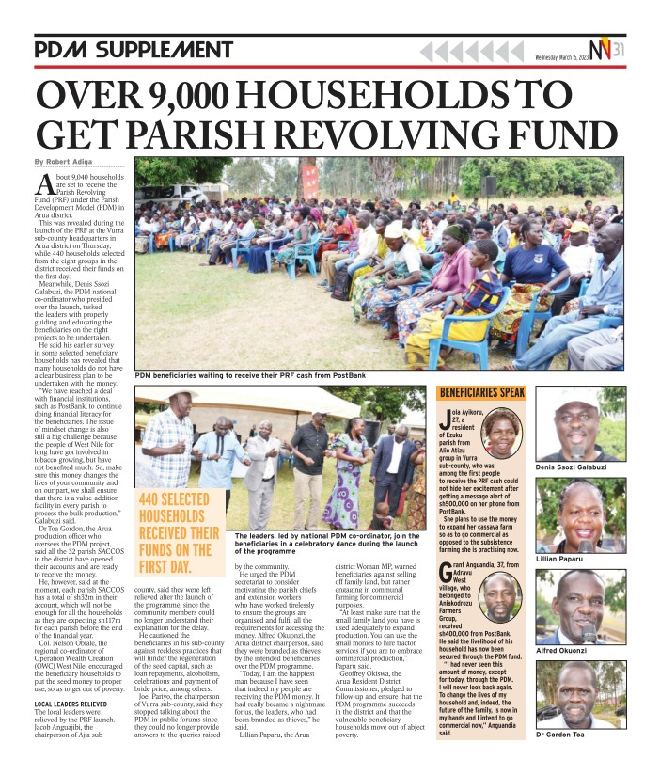

  - Training of Enterprise Groups and PDM SACCO leaders to manage the PRF: To improve the readiness of the PDM SACCOs, the Secretariat and MoFPED worked jointly with District PDM Core teams and private sector institutions, especially commercial banks, to deliver the necessary trainings and technical support, including governance and financial literacy sessions for PDM SACCO leaders.

  - Developed Cost Benefit Analysis Guides: MAAIF/Pillar 1 developed the Enterprise Selection Guide for both intensive and extensive enterprises (i.e., identification of viable enterprises (production with “Ekibaro”, “Cura, Mara”), to demonstrate Enterprise profitability, to guide Ugandans on profitable investment menu across the value-chain/enterprise selection for both intensive and extensive Enterprises of the seven PDM commodity enterprises, as guided by H.E. the President.

  - As such, another intervention was the training of subsisting Households on “Ekibaro/Cura/ Mara”) in the three sub-regions. With all this necessary infrastructure in place, the next phase of PDM implementation has been operationalisation of Pillar 1 (on Agricultural value-chain development i.e. production, processing, storage and marketing).

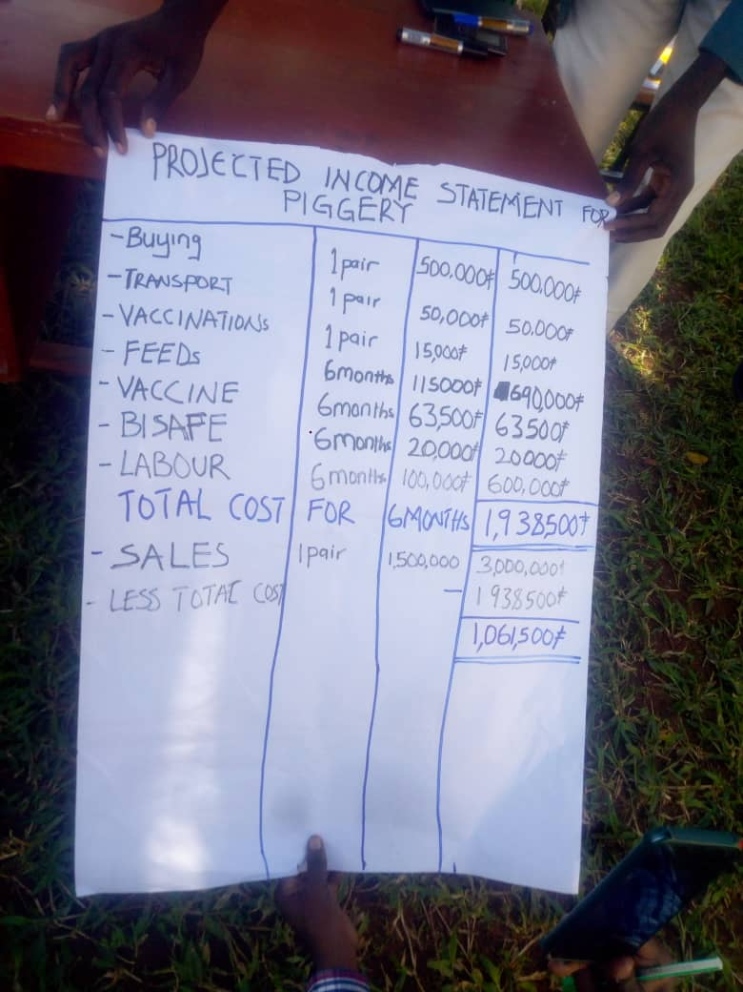

Case of Ekibaro, Bardege Division, Gulu City, March 2023

  - The above phase also largely relies on Data profiling (Pillar 6 on PDMIS), upon which to operationalize the Parish Revolving Fund (PRF) as one of the 6 components of Financial Inclusion - Pillar 3. As such, the following graphical presentation makes a summary of the 5- technical steps and community feedback followed in getting PDM SACCOs and beneficiary Households across the Local Governments in the said sub-regions ready for PRF (see Figure 1).

Figure 1: A 5-cycle training process for PDM leaders to manage the PRF
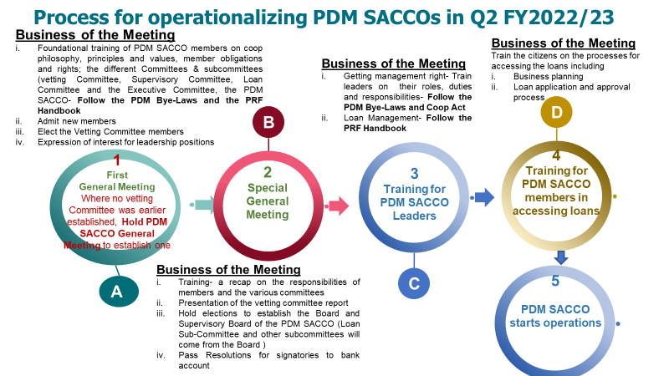

  - The achievement is that an initial lot of subsisting Households in Enterprise Groups that have been captured on the PDM-IFMS already registered a key milestone of having received PRF loans from a given PDM SACCO and beginning to invest in their respective enterprises, as summarised in Table 2 below:

Table: Indicative receipt of the PRF loans by Households in selected Districts in Lango, Acholi, W. Nile: as at 17th March, 2023
DLG/ MC/ City | No. of Parishes/ Wards having received PRF | No. of Households having received PRF
Zombo | 61 (Nyapea…..??) | 973
Arua DLG | 32 | 422
Koboko DLG | 49 | 45
Maracha DLG | 91 | 7
Amolatar DLG | - | -
Apac Municipality | - | -
Omoro DLG | - | -
Agago DLG | - | -

  - Rolling out of the PRF: Beyond those that have already disbursed, several other DLGs/ DLG/ Municipalities/ Cities in the three sub-regions have been/ or are also being prepared on readiness of PDM SACCO leaders and “Ekibaro”. In some areas, there is evidence of Households embarked/ are embarking on “Sweat capital” (i.e. their own investment contribution like labour for clearing land, digging up farm holes for seedlings) as part of Business plan in establishing or managing a PRF enterprise-supported loan as “Seed capital”.
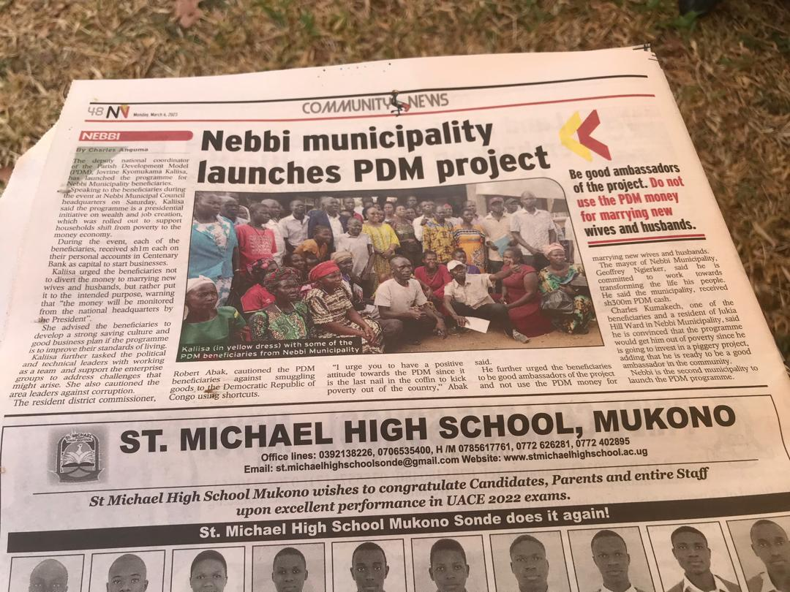
As such, several Local Governments are /or will soon launch and disburse PRF to the intended beneficiary subsisting Households. This is in spite of the fact that some wrong elements are still making all tricks and attempts to partake of the PRF, but will increasingly be weeded out through multi-institutional collaboration by Government structures like ISO, Uganda Police, ordinary people reporting, RDCs, as well as upon full data profiling/ PDMIS.

  - Guiding the Budget process on PDM: Through the PS/ST, both the Budget Execution Circular for FY 2022/23 (on 30th June 2022) and the 1st Budget Call Circular (on 15th September, 2022) were issued to all Accounting officers and chiefs of statutory bodies to guide on implementation and budgeting and for PDM. Going forward, therefore, greater compliance by MDAs and Local Governments in the three sub-regions is expected through work plans, in the operationalization of PDM (thus whole of Government approach) interventions.

  - Alignment of PDM with NDP III and NRM Manifesto: Similarly, the PDM is aligned to and NRM Manifesto, NDP III and other Government Programs by focusing on the “Whole-of-Government Approach” to service delivery and ensuring that Government interventions and Local Government work plans help to achieve NDP targets at household level and Agro-Industrialization objective. Within the Agricultural Sector for example, guidance has been extended that the Conditional Grants provided to the Local Governments be re-aligned in respect to achieving the PDM strategy and these include:

- Production and Marketing Grant
- Agriculture Extension Grant
- Micro-scale irrigation Program for the Uganda Intergovernmental Fiscal Transfer (UGFIT) reform program, and
- Agriculture Extension Wage.
Note that these resources are important for realization of Pillar 1 component of increasing production and productivity. Similarly, grants of other sectors should be seen as the means to implement PDM objectives in their respective Pillars.
  - Mapping Government and private sector storage and processing facilities for PDM: During the data collection process of the PDMIS, parish profiles are being formulated in form of Geo-spatial maps of infrastructure e.g., water sources, schools, health centers, processing facilities, storage facilities that are existing in that particular parish. This will help in planning for value chain development and alignment. Also arising from the Presidential- CEOs Forum & Private Sector Foundation Uganda (PSFU) engagements, it was established as critical to map all the Government, Cooperatives and other private sector storage and processing facilities. This will be the bedrock for minimizing post-harvest handling losses and high premium Market linkages under PDM objectives.

  - Mapping all Government interventions directly linked to PDM: Discussions and other efforts are already underway, to map all Government interventions that are directly relevant to Parish Development Model (PDM) implementation. For instance, the World Bank supported Uganda Multi-sectoral Food Security and Nutrition Project (UMFSNP) is a Government initiative jointly implemented through OPM, MAAIF, Ministry of Education and Sports –in 15 Districts across Uganda- including: Yumbe, Maracha, Arua City, Arua DLG, Madi-Okollo, Terego, Nebbi and Packwach; Ministry of Health; and, Ministry of Local Government. This intervention has strong convergence opportunities for PDM implementation by the State and Non-State Actors, so does CAIIP, NUSAF IV, MATIP for community modern markets to serve as business hubs for PDM and other agricultural produce and others.

  - Skilling through Rural Industrial Incubation Centers: Tagged to the various Agricultural Processing Facilities constructed by MDAs in the various Government Programmes and Projects of Non-State Actors, the Industrial Hubs which are implemented under Office of the President, provide a unique opportunity for skilling of farmers. The Secretariat of PDM engaged the Hubs Co-ordination office to explore synergies and preparedness for skilling of agriculture producers and processors in various areas, where these incubation centers have been constructed.

  - PDM strategy to work with Off-takers: PDM strategy is to work with medium to large-scale or extensive farmers as off-takers (markets) for the small-scale farmers doing intensive farming. The Secretariat together with the respective MDAs will continue to forge partnerships with the Industrial Parks; and big commercial farmers to encourage production of strategic commodities to meet national and international demand. Affirmative action to be given to sustainable fisheries sub-sector and aquaculture development in Uganda as a strategy both for PDM and protection of the wetlands.

  - Provision of tractors for Enhanced Production and Productivity: Tractors/implements with their accessories to enhance production and productivity were procured and distributed. Government has also partnered with some Non-State Actors to rationalize the availability of support to production and productivity – e.g. Action Against Hunger (AAH)in context of refugee- hosting communities. This CSO and partners have opened up over 10,000 acres of land in 2023 for agriculture. MoLG-PDM- AAH discussions on-going towards value-addition & expanded Tractor services in Adjumani & Yumbe.

  - MAAIF is promoting mechanization of agriculture: By providing tractors to the already organized Enterprise Groups-. All these efforts will be linked to the regional machinery maintenance centers of Government.

  - Initial Database for Certified agro-input dealers in place: A list of certified service providers across the country has been reviewed and the database construction is on-going; as well as teaching SMEs how to better manage agro-chemicals. The effort is for purposes of enabling Households to access certified input supplies to PDM production and productivity drive, including through the following:

- Prospecting partnership with Uganda Prison Farms for PDM: The PDM Secretariat in conjunction with Ministry of Agriculture (MAAIF) have embarked on prospecting for Uganda Prison Services to be part of the certified and high-quality agricultural input materials like crops, animal stock varieties and others through Prison farms, upon which to establish zonal supply centers to Households under their respective Enterprise Groups across the country.

- Working with National Agricultural research institution & Non-State Actors for PDM: There is a deliberate prospecting of working with National Agricultural research institutions, Non-State Actors and extension service delivery structures up to the Parish. The exercise further builds into scaling-up the county capacity for multiplication of clean seed, resilient crop technologies, livestock, fish and others, to respond to the national demand for certified and high-quality stocks of agro-inputs.
- Lira training on how to manage agro-chemicals. The sessions are to continue throughout the northern region.

3.0 KEY EMERGING ISSUES & RECOMMENDATIONS

S/N | EMERGING ISSUES | RECOMMENDATIONS/ ACTIONS
1 | Some Districts are not yet update with the PDM current phase of focus on Parish Revolving Fund | Trainings (by Regional TOTs & District PDM Core Teams) through the 5-phase stage will continue/ or be completed soon in preparing Households.
2 | Operational challenges – funds | Funds for PDM SACCO leaders, Technical & Political leaders will be sought …. Through the Budget.
3 | Poor data collection performance | Gap of Gadgets for Parish Chiefs to do Data collection will be addressed.
4 | Some funds yet to come to Parishes (.. Shs 17m, then Shs 100m…) | All funds expected should come by end of this FY.

CONCLUSION
Challenges notwithstanding, PDM is positively soldiering on, in confronting the violence of subsistence economy in northern Uganda & contributing to NRM Manifesto 2021-26. While we are engaged with the operational issues, we shall keep an eye on the strategic matters in the course of PDM implementation.

PDM Integrated Financial Management Information and Payment System

